

## VIVEKANANDA INSTITUTE OF PROFESSIONAL STUDIES - TECHNICAL CAMPUS

### Grade A++ Accredited Institution by NAAC

NBA Accredited for MCA Programme; Recognized under Section 2(f) by UGC; Affiliated to GGSIP University, Delhi; Recognized by Bar Council of India and AICTE An ISO 9001:2015 Certified Institution

**SCHOOL OF ENGINEERING & TECHNOLOGY**

# B.Tech Programme: CSE

Course Title: Data Warehouse & Data Mining

Course Code: CIE 425P

# Submitted To:

**Submitted By:**

**Name: Ishaan Jain**

**Enrollment No: 06117702722**

**Branch & Section: CSE B**

**Dr. Shalini Gambhir**

**Assistant Professor**



## VISION OF INSTITUTE

To be an educational institute that empowers the field of engineering to build a sustainable future by providing quality education with innovative practices that supports people, planet and profit.

## MISSION OF INSTITUTE

To groom the future engineers by providing value-based education and awakening students' curiosity, nurturing creativity and building

capabilities to enable them to make significant contributions to the world.

**EXPERIMENT - 1**

**AIM: Study of ETL process and its tools.**

**THEORY:**

**DATASET:**

**CODE:**

**# upload, read and print csv** import pandas as pd df = pd.read_csv('product_sales.csv') print("Original Data:") print(df)

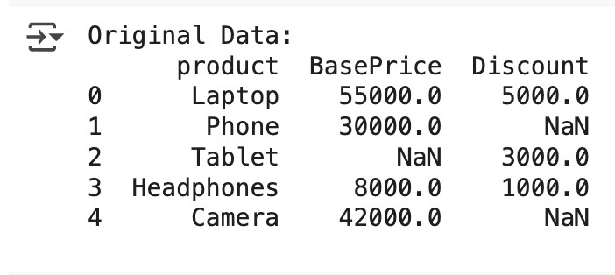

# #Missing values - mean of that column #for BasePrice

basic_mean = df['BasePrice'].mean() df['BasePrice'] = df['BasePrice'].fillna(basic_mean)

# # for Discount

bonus_mean = df['Discount'].mean() df['Discount'] = df['Discount'].fillna(bonus_mean) print("\nAfter Filling Missing Values:") print(df)

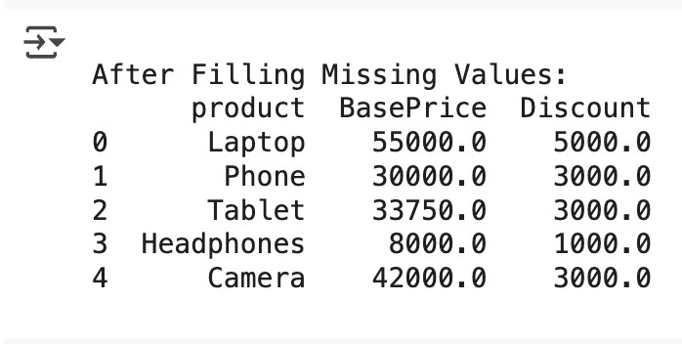

**# Create a new column 'FinalPrice'** df['FinalPrice'] = df['BasePrice'] - df['Discount'] print("\nAfter Calculating FinalPrice:") print(df)

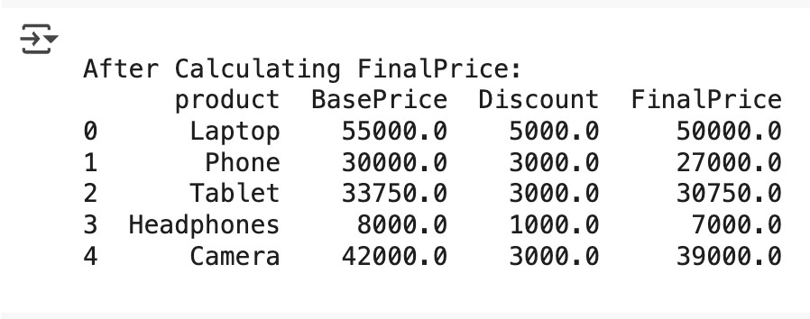

**# Define a function to calculate gst** def calculate_gst(FinalPrice): if FinalPrice >= 40000: return 0.18 * FinalPrice else:

return 0.12 * FinalPrice

**# new gst column** df['GST'] = df['FinalPrice'].apply(calculate_gst)

# Print after adding GST column print("\nAfter Adding GST Column:\n") print(df)

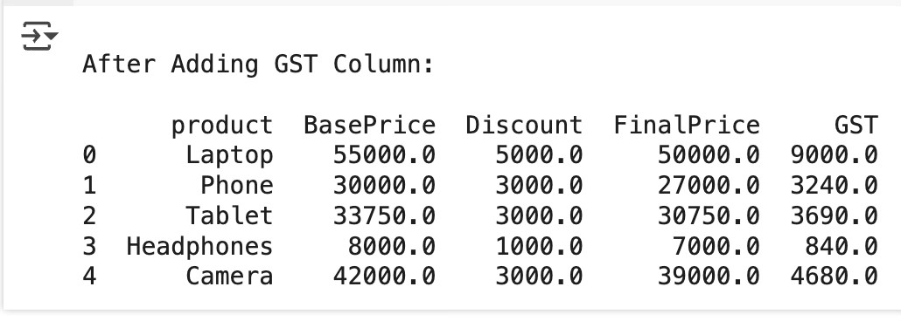

**# Save the transformed DataFrame** df.to_csv('complete_product_sales.csv', index=False)

#load and print the new file transformed_df = pd.read_csv('complete_product_sales.csv') print("\n New Updated File \n") print(transformed_df)

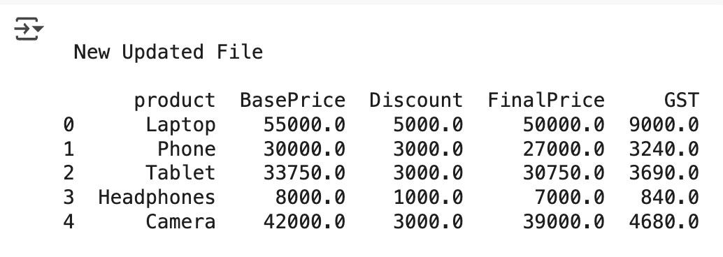

**OUTPUT:**

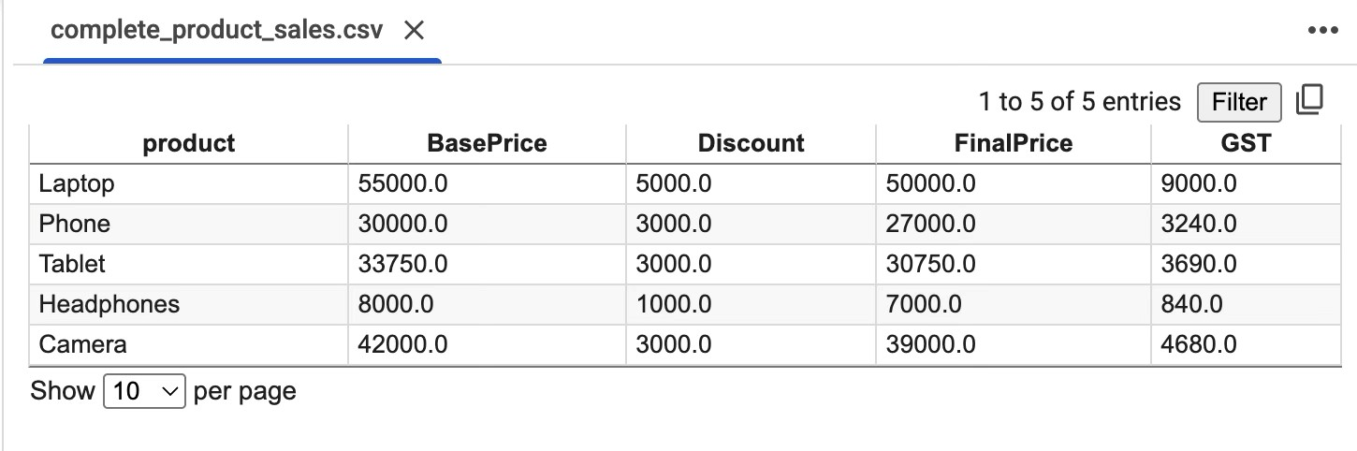

**LEARNING OUTCOME:**

# EXPERIMENT - 2

**AIM: Program of Data warehouse cleansing to input names from users (inconsistent) and format them.**

**THEORY:**

**DATASET:**

**CODE:**

import re

def clean_name(name: str) -> str: name = name.replace("@", "a") name = name.replace("!", "i") name = name.replace("0", "o") name = re.sub(r'[^A-Za-z\s]', '', name) name = " ".join(name.split()) return name.title()

print("Enter 'exit' to stop.") while(True):

name = input("Enter name: ") if(name == "exit"):

break

print("Cleaned Name : ",clean_name(name),"\n")

**OUTPUT:**

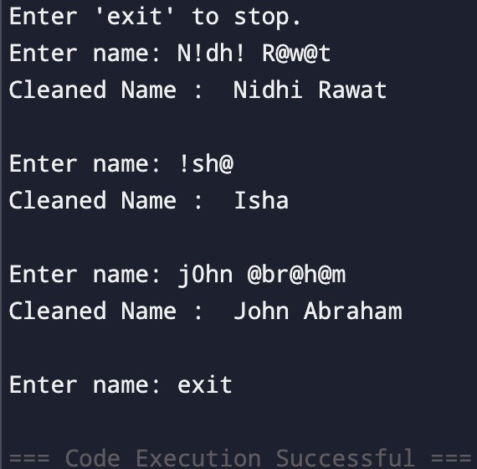

**LEARNING OUTCOME:**

# EXPERIMENT - 3

**AIM: Program of Data warehouse cleansing to remove redundancy in data.**

**THEORY:**

**DATASET:**

**CODE:**

from fuzzywuzzy import fuzz import pandas as pd import matplotlib.pyplot as plt

## #Load csv

df = pd.read_csv("dataset/customer_data.csv") print("Original Dataset:\n", df)

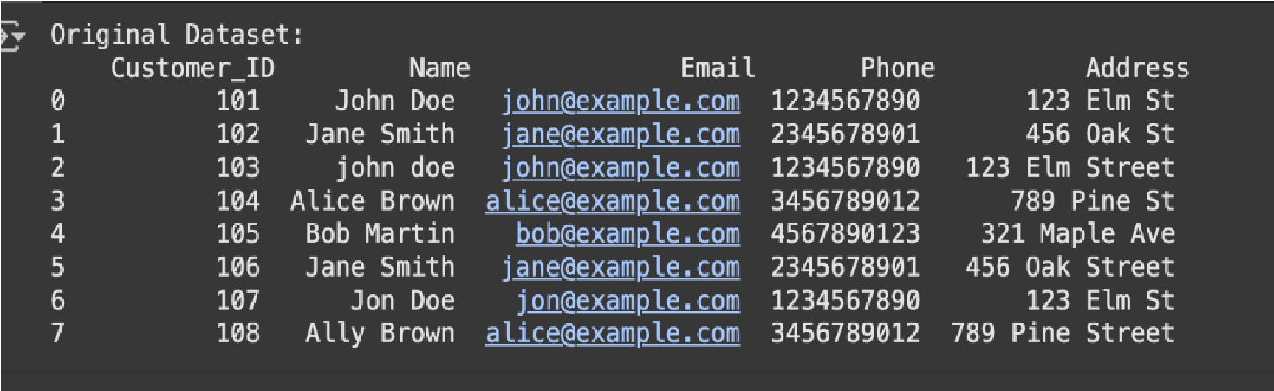

## #Standardize names and addresses

df['Name'] = df['Name'].str.strip().str.title() df['Address'] = df['Address'].str.strip().str.title() print("\nAfter Standardization\n", df)

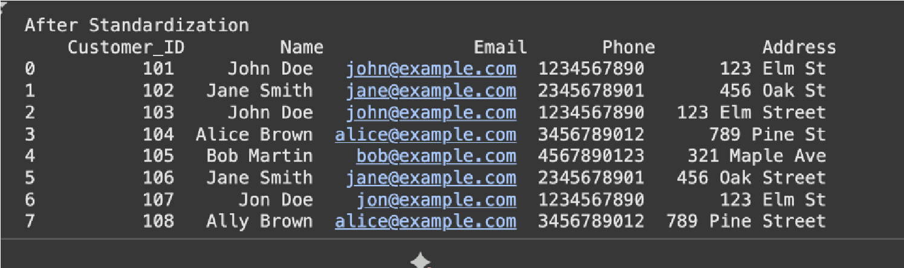

**#Remove exact duplicates** df_no_duplicates = df.drop_duplicates() print("After removing duplicates\n", df_no_duplicates)

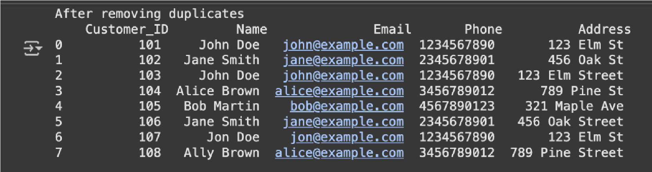

**#Detect near Duplicates using fuzzy matching** names = df_no_duplicates['Name'].tolist() print("Potential Near Duplicates"); for i in range(len(names)): for j in range(i + 1, len(names)):

similarity = fuzz.ratio(names[i], names[j]); if similarity > 80: # Threshold for near duplicates print(f"'{names[i]}' and '{names[j]}' (Similarity: {similarity}%)")

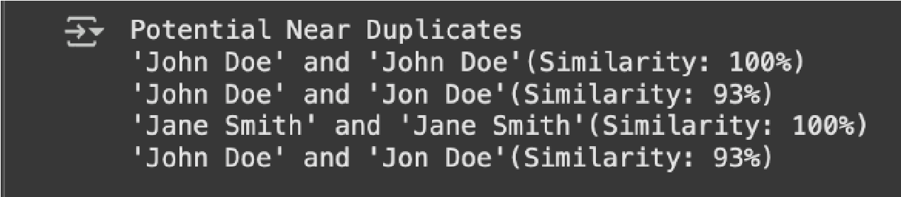

df_no_duplicates=df_no_duplicates.drop_duplicates(subset= ['Phone'], keep='first') print("After Removing Duplicates : \n", df_no_duplicates)

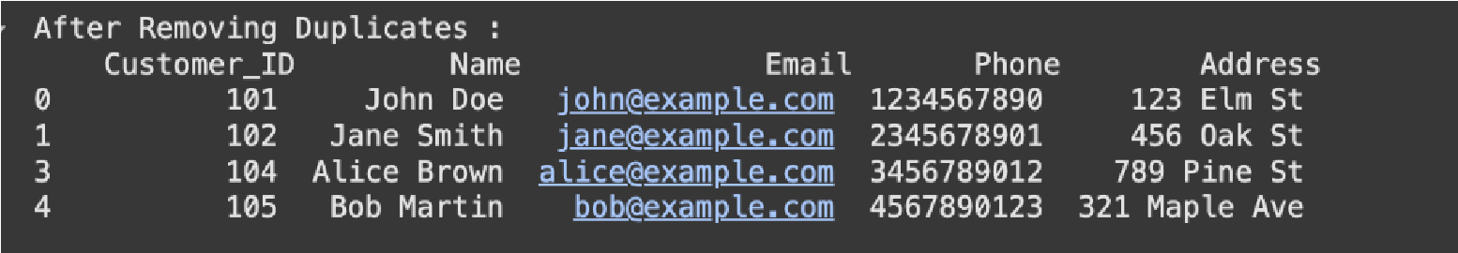

plt.figure(figsize=(8,4)) df['Name'].value_counts().plot(kind='bar', color='blue')

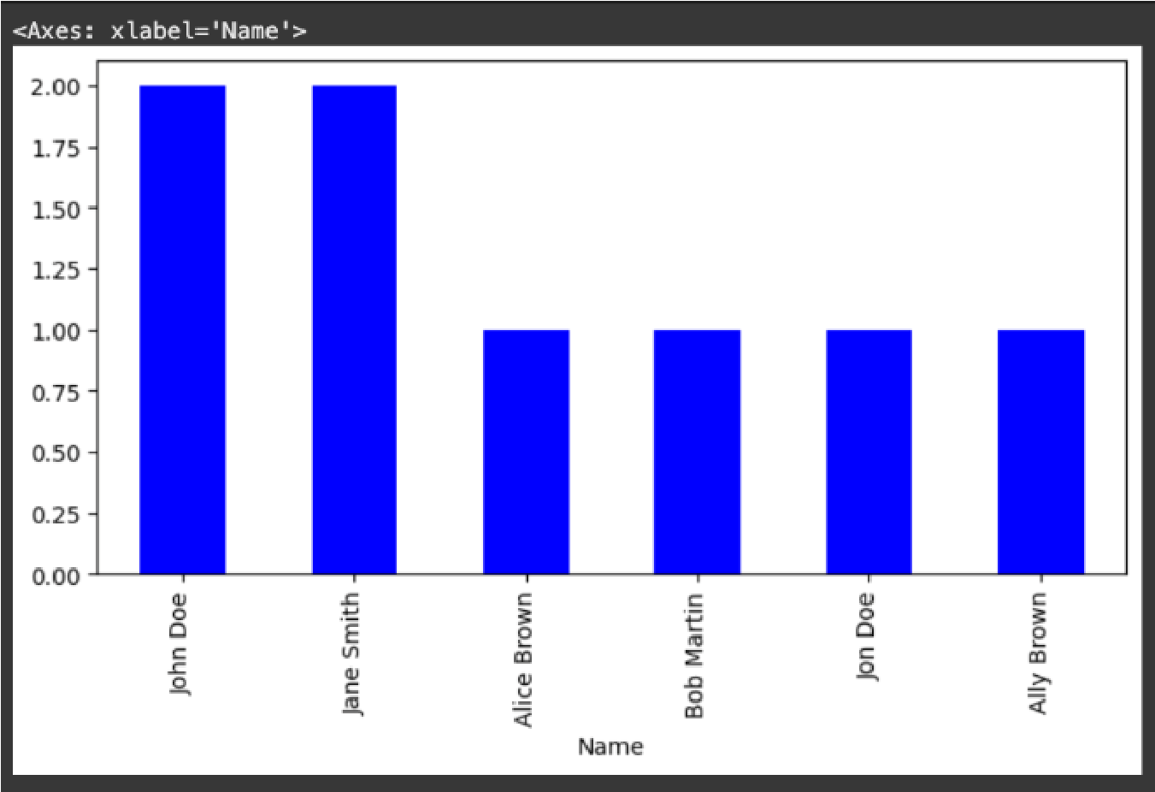

plt.figure(figsize=(8,4)) df_no_duplicates['Name'].value_counts().plot(kind='bar', color='blue')

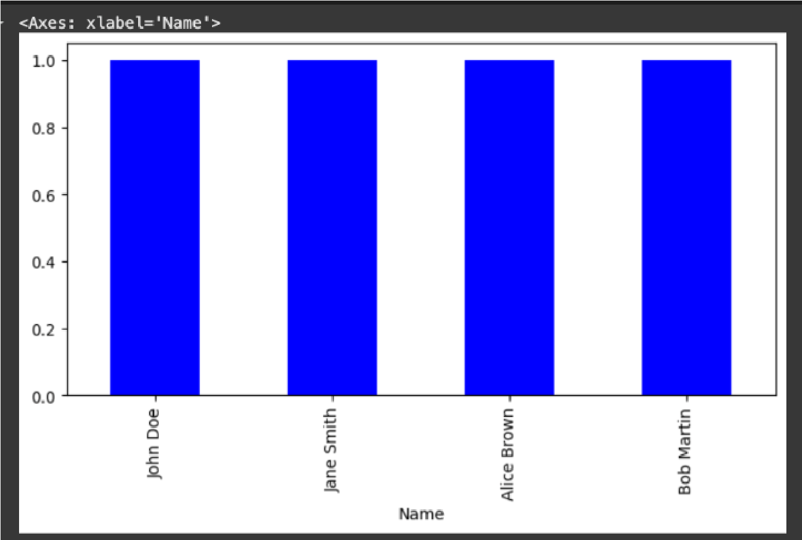

df_no_duplicates.to_csv("cleaned_data.csv", index=False) print("File Saved”)

**OUTPUT:**

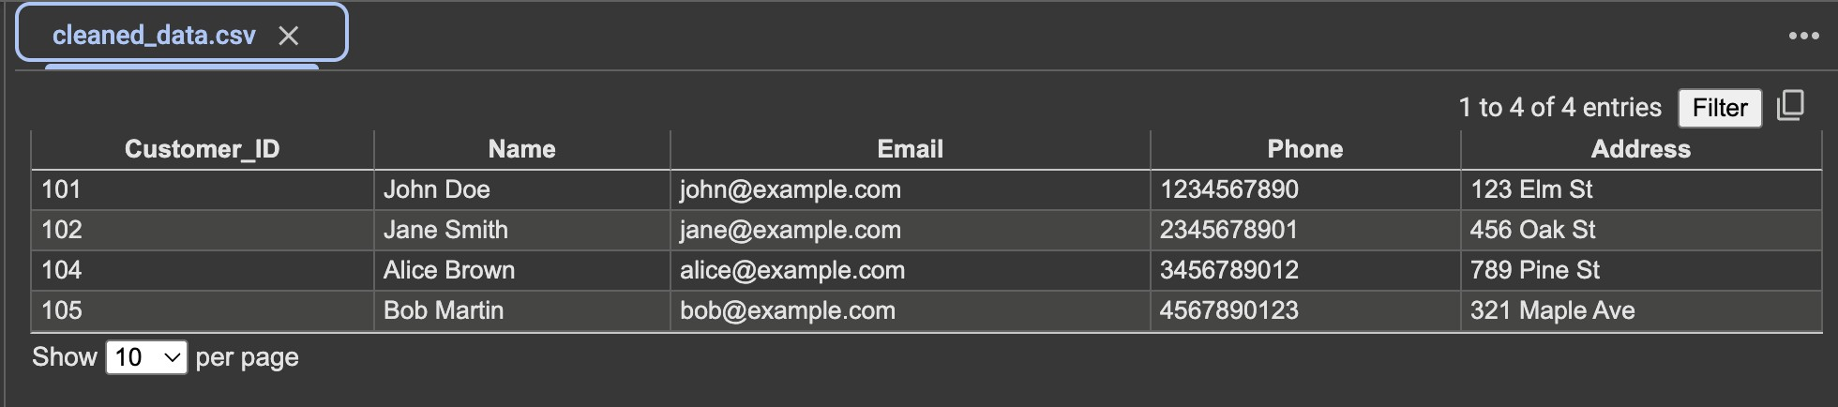

**LEARNING OUTCOME:**